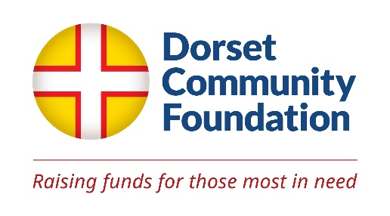**GIFT AID DECLARATION**

**In order to Gift Aid your donation you must tick the box below:**

I want to Gift Aid my donation of £_ and any donations I make in the future

or have made in the past 4 years to the Dorset Community Foundation.

I am a UK taxpayer and understand that if I pay less Income Tax and/or Capital Gains Tax than the amount of Gift Aid claimed on all my donations in that tax year it is my responsibility to pay any difference.

Please notify Dorset Community Foundation if you wish to cancel this declaration, change your name/home address, or longer pay sufficient tax on your income and/or capital gains.

If you pay Income Tax at the higher or additional rate and want to receive the additional tax relief due to you, you must include all your Gift Aid donations on your Self-Assessment tax return or ask HM Revenue and Customs to adjust your tax code.

**Title Initial Surname**

**Home Address**

**Post code Email**

**Signature Date**

***Please tick the boxes below to indicate ways for us to contact you.***

*Under new regulations we can continue to inform you of our work only if we have your explicit consent via the methods specified below.*

**By Email**

**By Post** (at the address above)

**By Phone**

***Please let us know what updates you would like to receive:***

**All Newsletter Grant Alert Events Publications**

**Please return this form to: admin@dorsetcf.org**