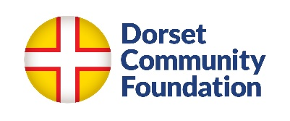
Lead the Change Fund
Expression of Interest form

Name of organisation

Type of organisation
e.g. charity, CIC limited by guarantee, company limited by guarantee, exempted charity

Charity / company number

Annual Income

Partnership bids (optional)
You can work with up to 2 partner organisations if you choose to - partner organisations are organisations that will receive some of the grant funds.

(You can also collaborate with other organisation that will not receive grant funds.)

For partnership bids, please name your partner organisations and what type of organisation they are

Primary contact name and contact details

Location of work

Summary of project
Please provide a brief description of the organisation's proposed project, to including how young people will be involved in design & delivery, links to contextual safeguarding and trauma-informed approaches, and how you will encorporate youth voice (200–300 words).

Youth voice
A brief description of how you currently incorporate youth voice in your organisation.

Indicative budget
Budget must total £123,353

If this is a partnership bid, please indicate which partners will receive funds, approx how much and what for

Please confirm you have a Safeguarding policy in place in the name of your organisation
Yes/no

Do your partner organisations have a Safeguarding policy in their own name?

Please email your completed form to grants@dorsetcf.org by 21st April. We will not accept applications after this date.

